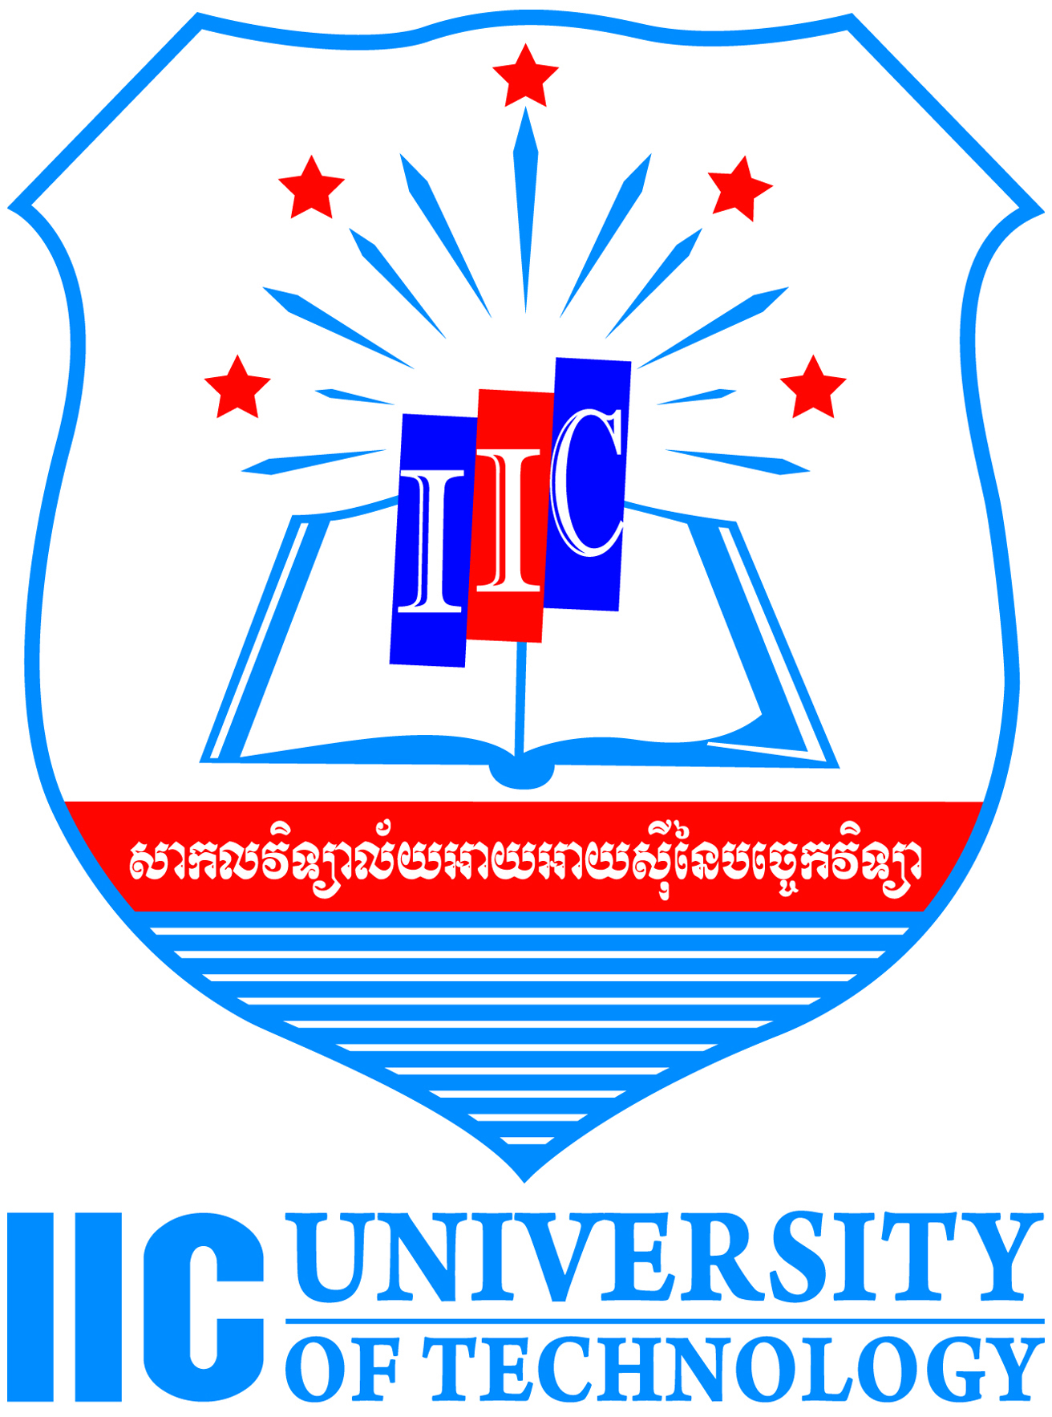

Application Guidelines

Should you experience difficulties with the application process, please email: info@iic.edu.kh/n.sreytouch@iic.edu.kh

Proposed programme of study

The Admissions Committee will be looking for strongly focused research outlines/research proposals. Applicants are advised to apply for only one programme.

English Language Section

If Bachelor Degree/ Master Degree is not in English, you are required to complete personal statement to show your proficiency in English.

Personal Statement Section

This should consist of a clear explanation of your motivation for applying for the PhD Approximately one half to a page of A4 is appropriate. We do not require or consider CVs. If preferred, you may write your personal statement in a separate document and upload it to attach it with your application. If you have any anomalies in your education that you wish to explain, please use this section to give a brief explanation.

Research Proposal (PhD/ Industry PhD)

Optional – You are encouraged to submit ONLY When appointment of Supervisor.

- You are required to submit a research proposal with your Application.
- The proposal should be of approximately 3,000 words.
- The proposal should include a preliminary title and set of questions and a discussion of your proposed approach, identifying the sources you intend to use, with a brief critical survey of the key sources you already know, along with an acknowledgement of current debate within the field.
- You should describe your motivation for selecting this particular topic for research, and state why you think your proposed work will make a significant and original contribution to the field.
- Whilst the Admissions Committee appreciates that this proposal will change through the course of your research, you should endeavour to present a project which will be considered feasible within the framework of an Industry PhD programme, including a preliminary timetable.
- The Committee places great importance on the originality, substance and feasibility of your proposal. Candidates are encouraged to take due care in the preparation of the proposal, to choose their own supervisors.
- Applicants may wish to consult P. Dunleavy, Authoring a PhD: How to Plan, Draft, Write and Finish a Doctoral Thesis or Dissertation (Palgrave Macmillan, 2003) for advice on how to formulate a research problem and plan a doctorate.

Supporting Documents

References
- You should nominate two referees who are familiar with your academic work and ideally who know of your proposed field of research and it is your responsibility to make contact with your referees promptly to allow your application to be completed in time. Please note that outside term time many academics may be away from their College and therefore difficult to contact.
- Please contact your referees and ask them to submit their references email at info@iic.edu.kh

Transcripts
- You are required to attach academic transcripts (not certificates) of your undergraduate and postgraduate degrees with your application. If you have yet to complete your degree, the transcript must list your marks gained so far.
- Academic transcripts can be obtained from your College Registry/Student Records office. They may charge a small fee for this. It is your responsibility to request these documents in good time.
- Foreign language transcripts: if your transcript is not in English, you must obtain an official certified translation from your College. If your College does not provide this service, you should contact your local British Council office or your own country’s embassy, which should be able to do this.
- All transcripts must be signed and/or stamped by the Registry to show authenticity. If you are having difficulties obtaining this, please contact your department/faculty office who should be able to provide you with a letter on headed paper listing your courses and marks which must be stamped with the College seal.
- Should you be offered a place on the programme to which you applied, you will be expected to bring the original documents with you to enrollment.

English Language Certificate
- Please refer to the English Language Section above for the requirements.

You should arrange for the Supporting Documents to be sent to you so that you can attach them to your application.

Check List of Application

- Application forms
- 2 Copies of Referee form
- Certified true copy of
  - Degree transcripts and certificate
  - Master transcripts and certificate
  - Relevant documents
- Application Fees of USD 50.

Name of the Banking Institution ACLEDA Bank Plc.

Bank's Address #61, Preah Monivong Blvd., Sangkat Srah Chork, Khan Daun Penh, Phnom Penh, Cambodia

Telephone number +855 (0)23 994 444, +855 (0)15 999 233
Facsimile number +855 (0)23 430 555 inquiry@acledabank.com.kh
E-mail limkunthea@acledabank.com.kh yimnat@acledabank.com.kh

SWIFT ACLBKHPP
Account with institution  FIELD 57A: | ACLEDA Bank Plc., Head Office, Phnom Penh, Cambodia. SWIFT CODE: ACLBKHPP  CHIPS UID: 415637
Beneficiary Customer  FIELD 59: | Name: IIC UNIVERSITY OF TECHNOLOGY  Account No.: 2400 00 122798 20
Details of Payment  FIELD 70: | Payment for tuition fee

